(Approx. 697 words)

The Internet Is My Cookbook
Searching for Recipes
Author: Tom Burt, Vice-President
Sun City Summerlin Computer Club
September 2019 issue, Gigabyte Gazette
www.scscc.club
tomburt89134 (at) cox.net

An oft-spoken motto around Casa de Burt is “Fight Boring Food.” Most nights we stay home and cook, as this gives better portion and ingredient control. We enjoy ethnic food – especially Indian and Thai, though our repertoire includes all cuisines. Another challenge is coming up with recipes that work well for two. Often, we plan for a second meal as a way to get double duty from the original preparation.

As part of the menu planning process, we sit down mid-week, after the supermarket flyers have arrived, along with an inventory of what’s in the freezer and refrigerator. We then figure out the dinner plan for the following week. Each dinner typically includes a protein, a starch and a vegetable or salad and some fruit. Once we have a general plan, the challenge is to decide how a given meal will be cooked. The goal is to have lots of variety while keeping cost and effort low.

For example, we might decide to have chicken one evening. Will it be boneless-skinless breasts or thighs or a whole roast chicken or do we boil a chicken to make soup or we do cut up the chicken and do it oven fried or perhaps a pan fricassee? Another night it might be beef - steak, pot roast, braised brisket, fajitas, carne asada, roast prime rib, sweet and sour? And so on. The choice of prep for the protein in turn drives the choice of starch – rice, potatoes, egg noodles, pasta, bread and so on – as well as the choice of veggies or salad.

Often, especially for a preparation we haven’t done for a while, I like to fire up my favorite web search engine and get an idea of how a particular dish is prepared. Usually I’ll look over a dozen or so recipes to get a sense of what ingredients are fundamental to the dish, cooking time and temperature and any special techniques. Most dishes also involve a sauce or gravy. Once I know what it will take to make the dish, I note any unusual ingredients (e.g. fresh ginger, cilantro, coconut milk, scallions, tortillas) on the shopping list.

Now that I’ve got you salivating, let’s look at a couple of real-world examples.

All recipe searches should start with RECIPE followed by your protein (or perhaps veggie), followed by the preparation. For example: RECIPE CHICKEN TIKKA MASALA EASY. Adding the qualifier EASY to your search homes in on recipes that don’t have a lot of complex ingredients or preparation. Chicken Tikka Masala is actually a dish made popular in Britain, using Indian spices, chicken, tomato sauce and plain yoghurt. My search on Google turned up 3,260,000 hits – a few too many to read. But the top 10 or so provide all the essential information.

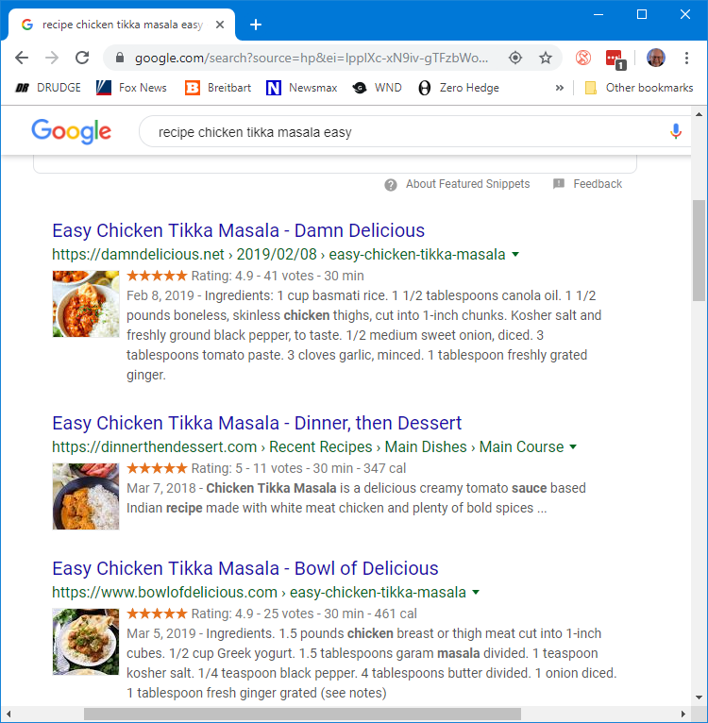

Many of the resulting recipes have star ratings that help you home in on ones that produce the best results. Clicking on a link takes you to the website where the details of the recipe – ingredients and preparation steps are detailed. Many of the recipes also have calculators to let you adjust the ingredients to the number of portions you want to make. Many also have lots of photos or even videos to help less experienced would-be chefs to understand the preparation.

Let’s try another search: RECIPE LAMB GOULASH EASY

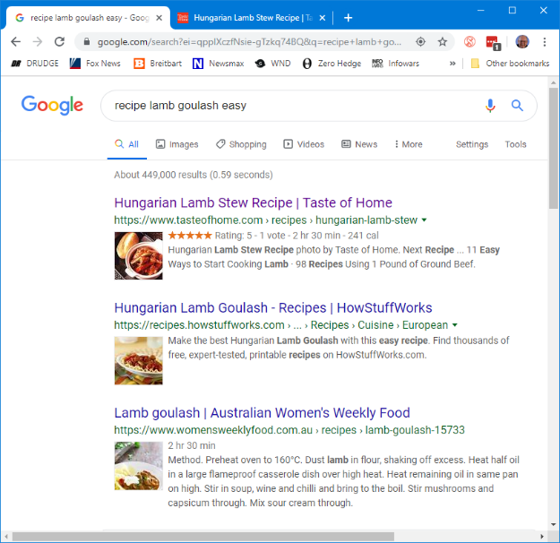
This one got 449,000 hits. The rating on the top recipe is 5 stars, so it should be pretty good. Goulash is a Hungarian spicy meat stew made with meat, onions, tomatoes, bell peppers, garlic, and lots of paprika. It’s a single pot meal that’s served in a bowl, so very easy on prep. There are many variations of the meat and veggies.

The recipe possibilities on the Internet are endless and no matter what you’re looking for, the web will serve up a recipe for you. If feeling adventurous, try searching for:
RECIPE DUCK A-L'ORANGE or RECIPE AVGOLEMONO SOUP
Let your imagination be your guide and, in the words of noted French chef Jacques Pépin, “Happy Cooking!”.

